**Promotional Task 3**

This is a brief walk through of my working process for this task.

**Step 1:** **Creating a Vagrantfile and Provisioning Scripts -** I’ve used the define method to define two different VMs for a web server and a DB server, each with its unique configuration.

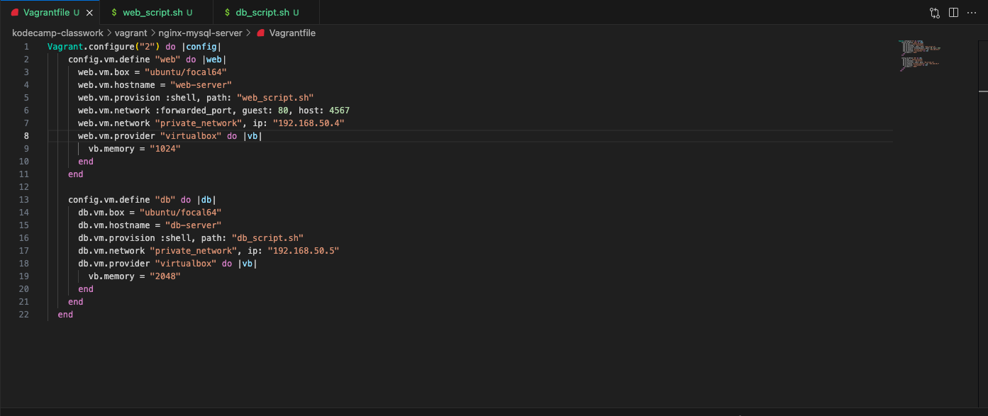

The web VM named web-server is based off of an ubuntu/focal64 box, with port forwarding set up to forward port 4567 on host to port 80 on the guest. The VM is also set up to communicate over the network with the address 192.168.50.4. I’ve also used virtual box as my provider, allocating 1024mb of memory to it. Finally, it’s provisioned using the shell script below, where I’ve installed nginx and mysql-client and also made /var/www a symlink to /vagrant (my shared folder).

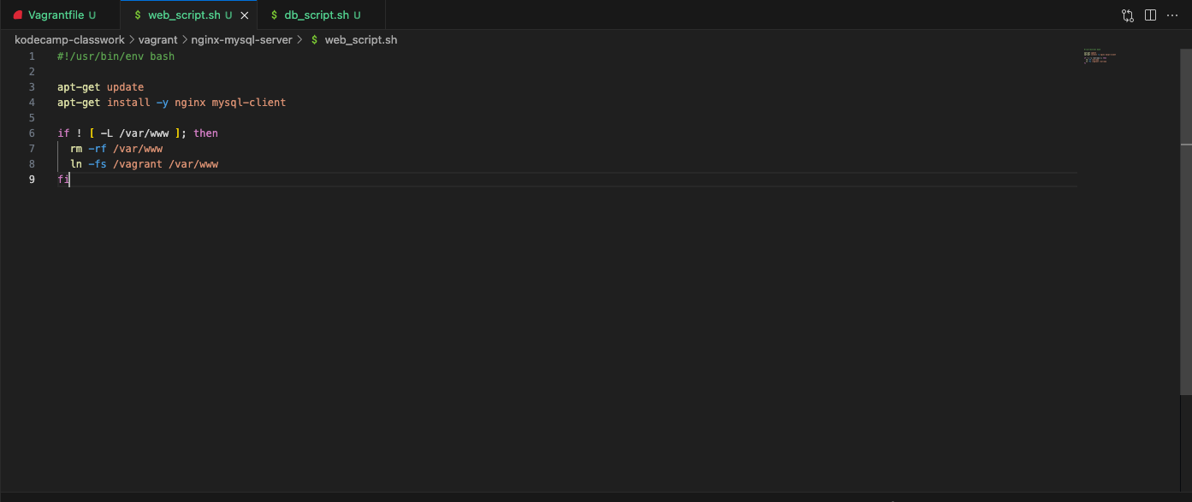

The DB VM named db-server is based off of an ubuntu/focal64 box. The VM is also set up to communicate over the network with the address 192.168.50.5. I’ve also used virtual box as my provider, allocating 2048mb of memory to it. Finally, it’s provisioned using the shell script below, where I have installed mysql-server and run a few mysql commands to create a user and a database and grant the user access to the database. Also I have allowed connection to mysql-server from anywhere to allow us to connect from our web server.

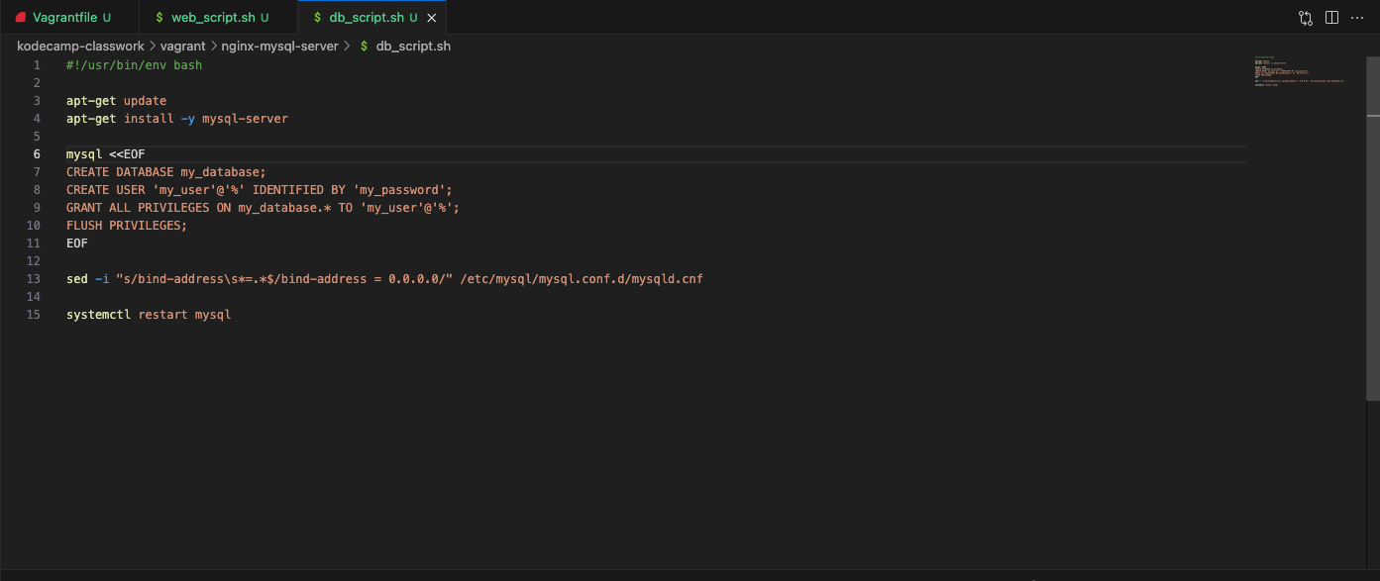

I have also added a toy project I did a while ago to the project directory as I’ll be serving this to test my web server. Here’s what my working directory looks like.

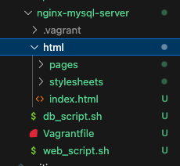

**Step 2: Provisioning The Machines -** To provision the VMs I used the command ~$ vagrant up.

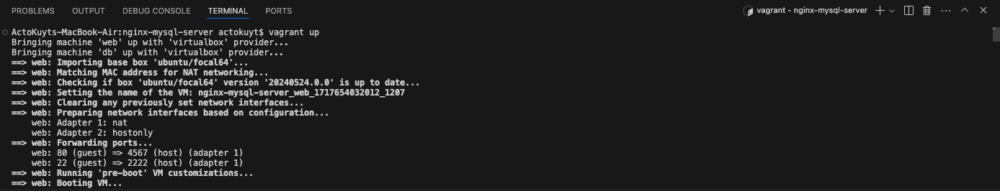

Then I accessed the VMs using ~$ vagrant ssh <VM name>.

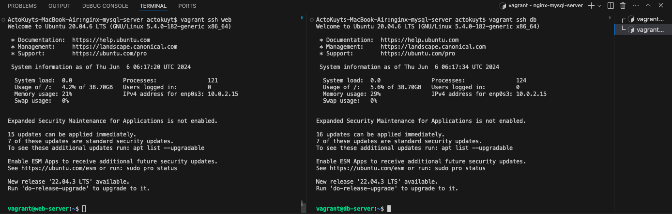

**Step 3: Testing -** Now everything seems to be ready, let’s do a few things to confirm that we’re up and running. Firstly, I’ve checked to see that my packages were successfully installed.

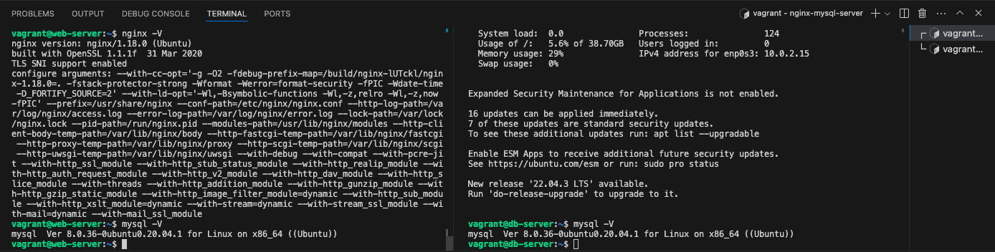

Next, I visited localhost:4567 on my browser to confirm my web server is correctly serving my static web page.

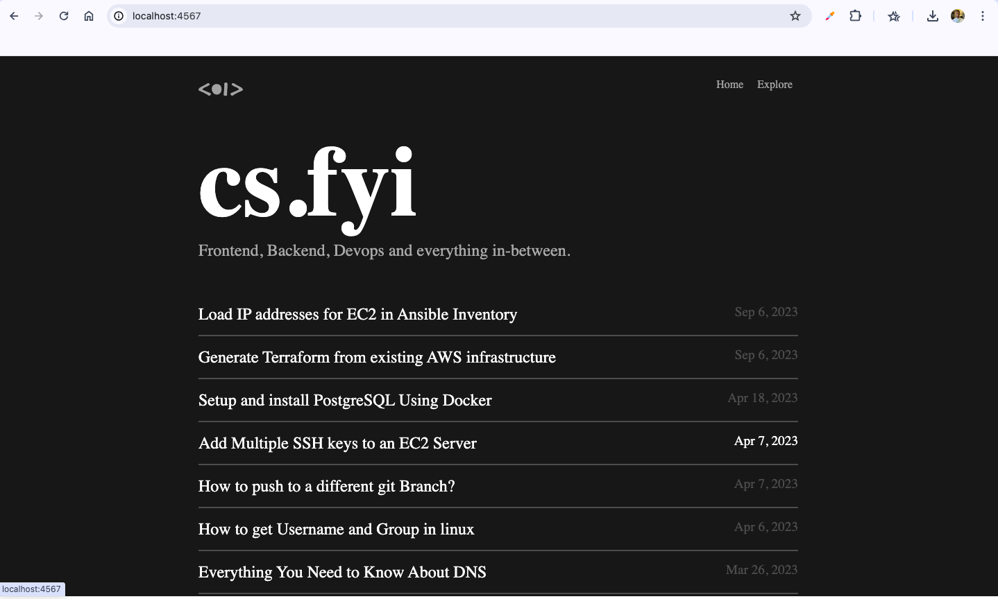

Finally, I tried to access the db from my web server using the command ~$ mysql -h -u -p. I also was able to run the mysql command “show databases” to view the database that was created during provisioning.

